WORK 5

***Herring Catch* – a 1% for Art project**

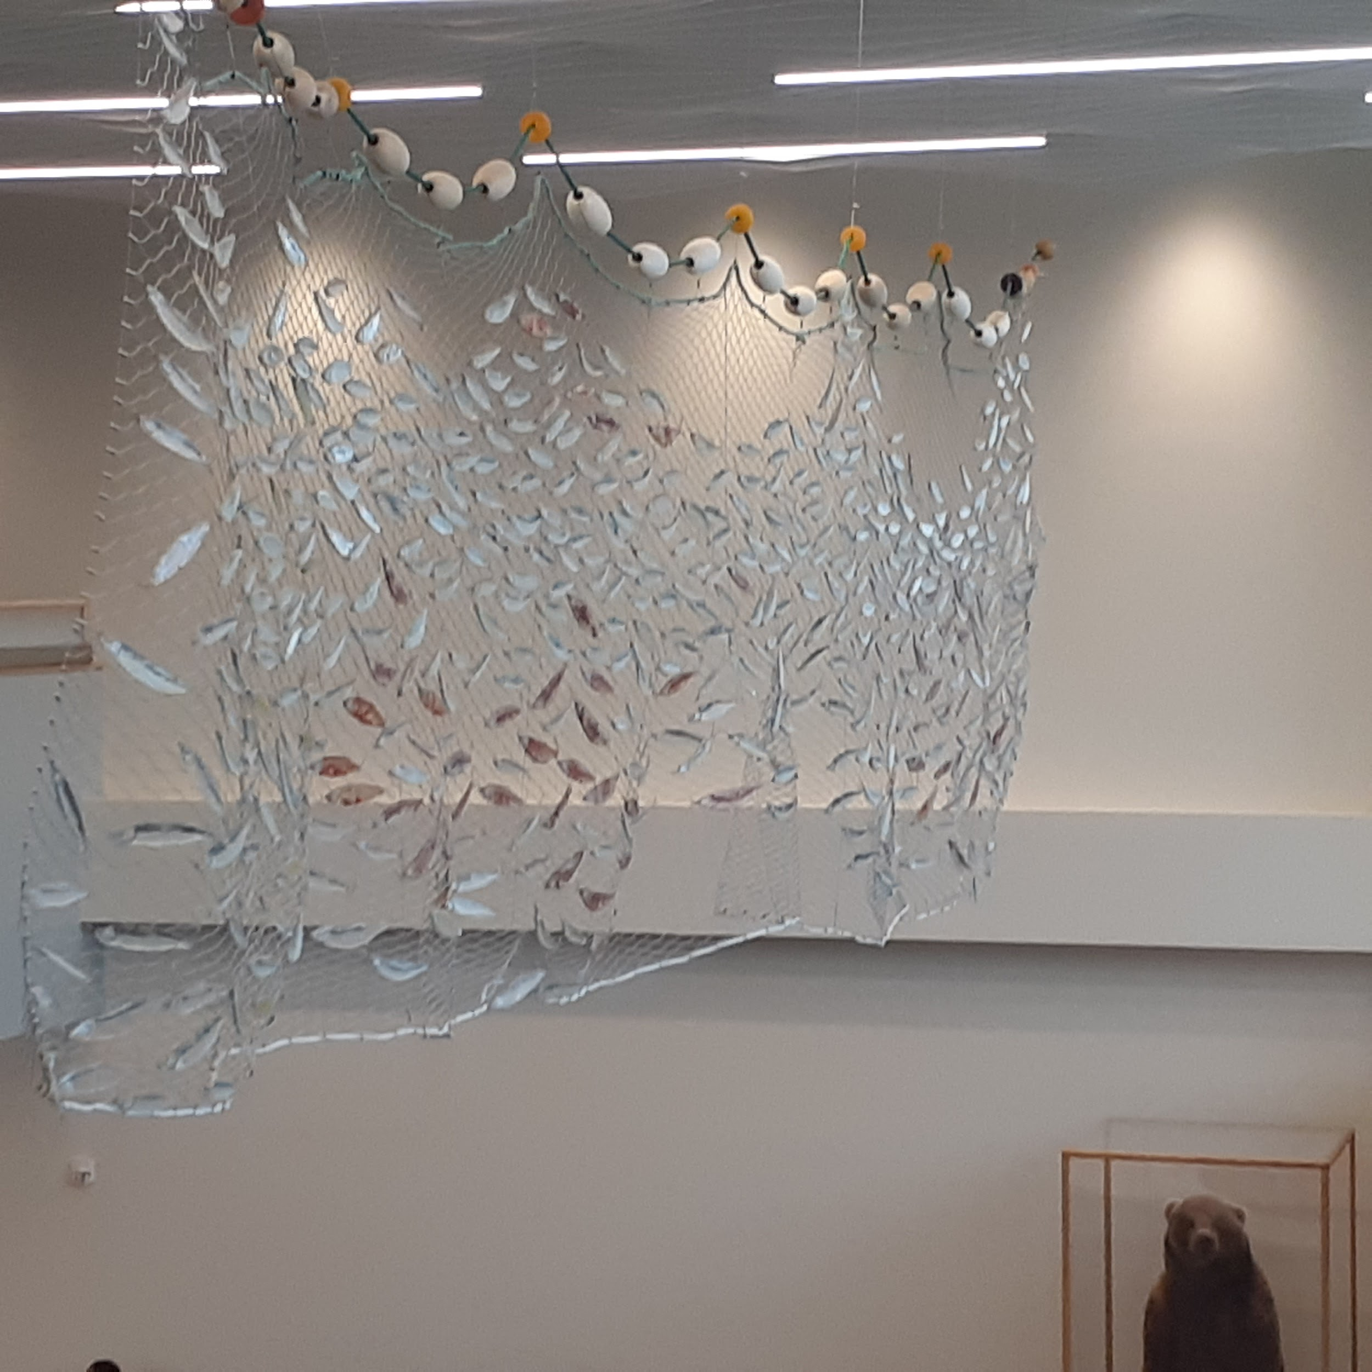

*Herring Catch*

Juneau International Airport

2021

Completed in June of 2020 and funded by a 1% for Art Award, *Herring Catch* is inspired by —and an ode to— the keystone species of herring and our fishing industry in Southeast Alaska.It reflects a small haul of herring, flecked throughout with clatters of red herring. Herring is integral to the communities and wildlife throughout Alaska, and I’ve tried to highlight the importance of this critical forage fish as well as to illuminate the dire ecological and environmental changes that are impacting herring and the fishing industry at large.

Every herring I create is designed from scientific research photos and personal catches. They are true to size, scale, and have the physical properties of herring caught in this area. Each individual fish is cut from multiple layers of sheet glass, hand printed and assembled with metal inclusions before kiln fusing. The herring were then hung in a pattern of swimming into and getting caught in a net. The suspended stainless steel net is adorned with reclaimed fishing line and corks as well as numerous cast glass corks.

With this work I hope to readily engage and educate the public on environmental issues facing herring while bringing these issues to light through artistic interpretation and a highly impactful and beautiful visual language which is accessible to all.

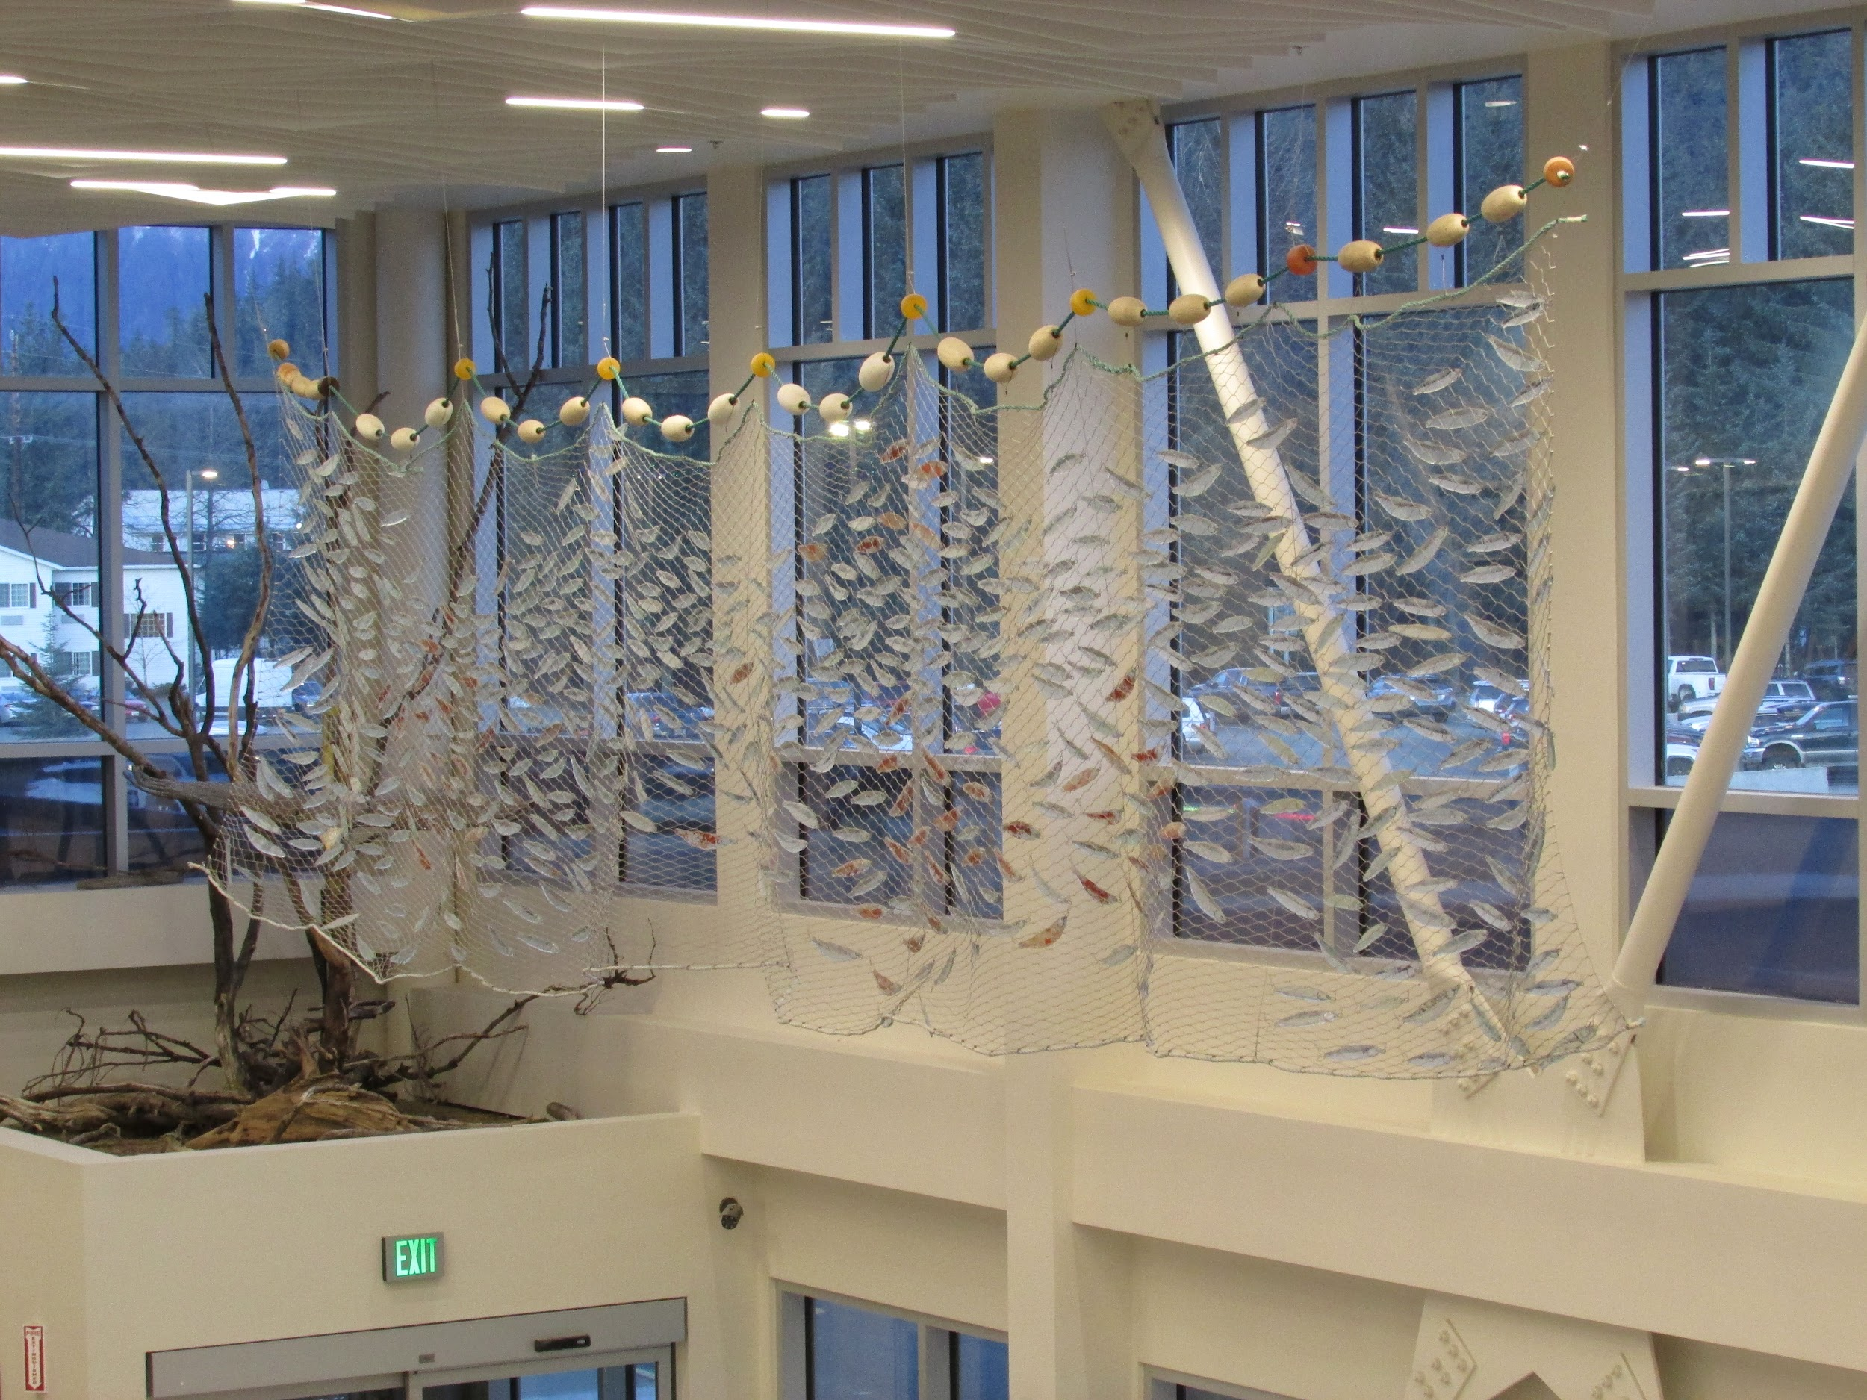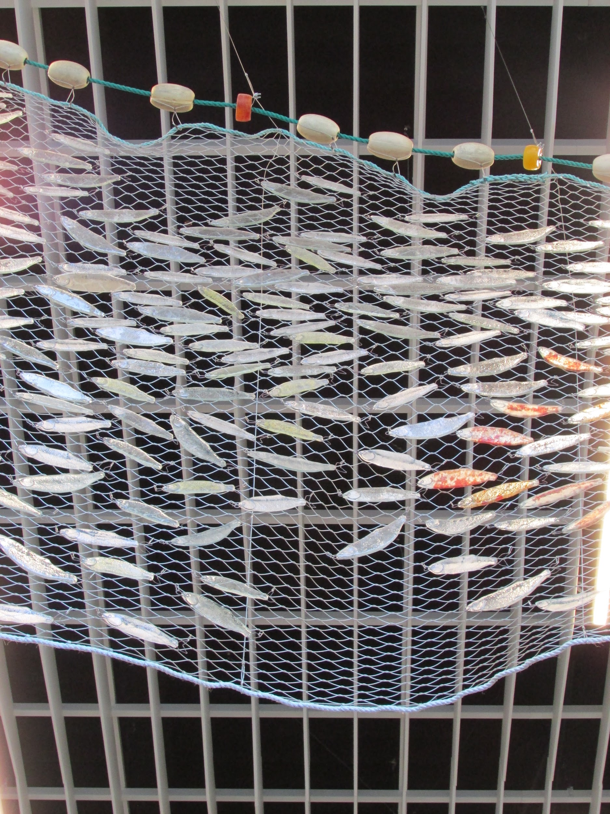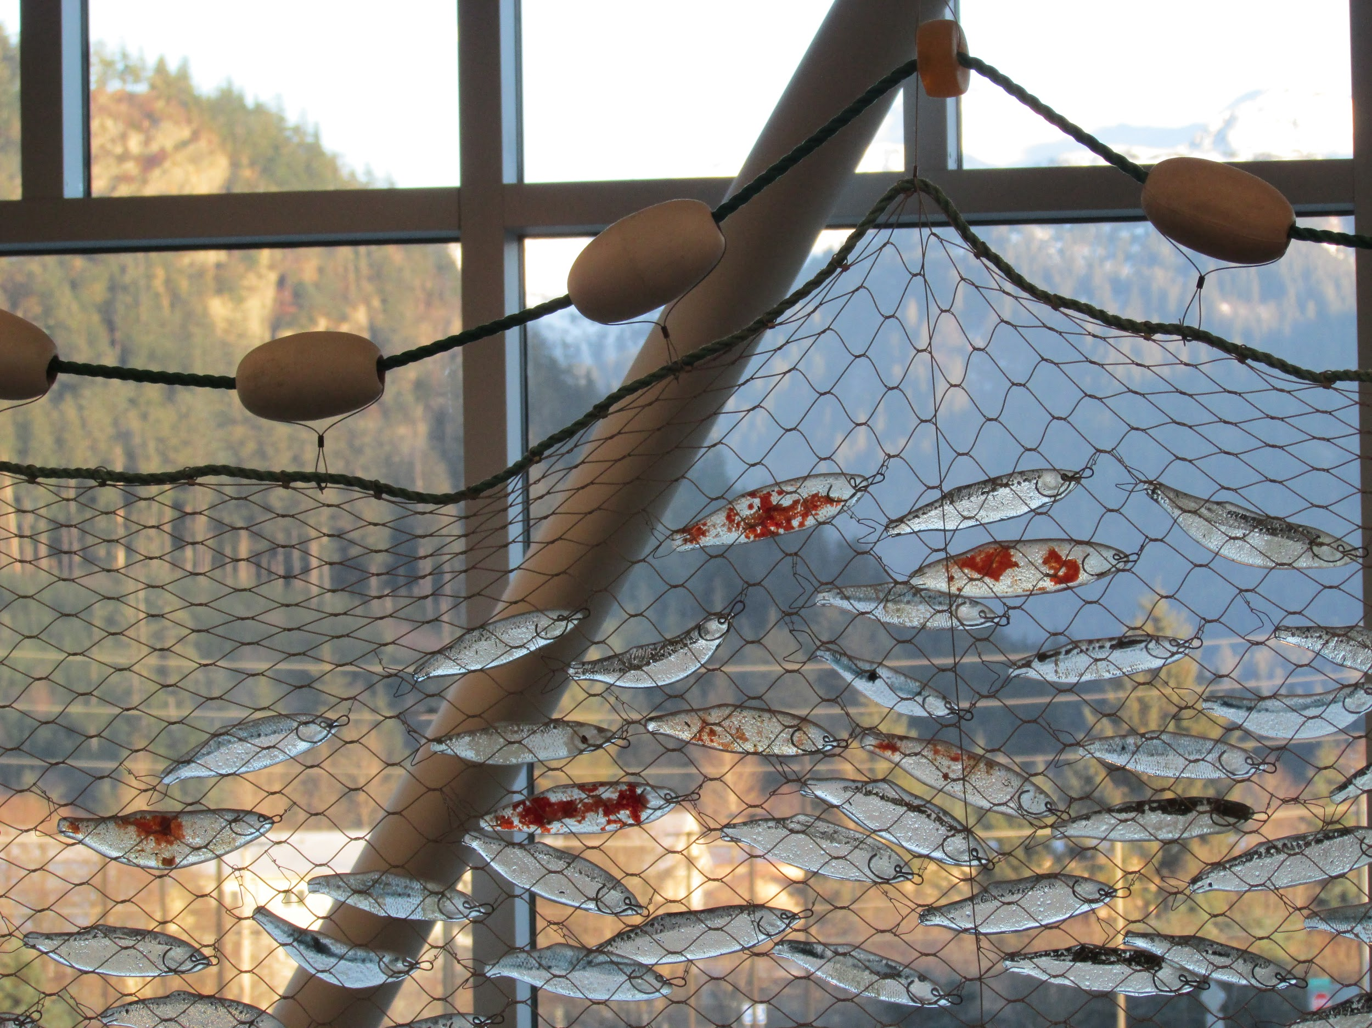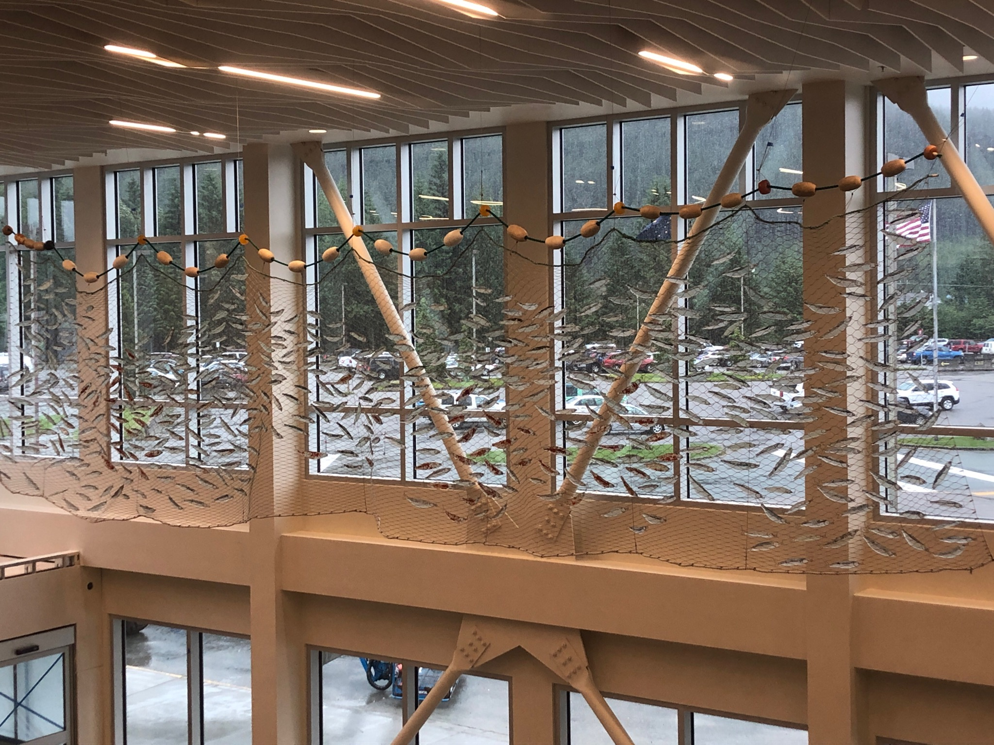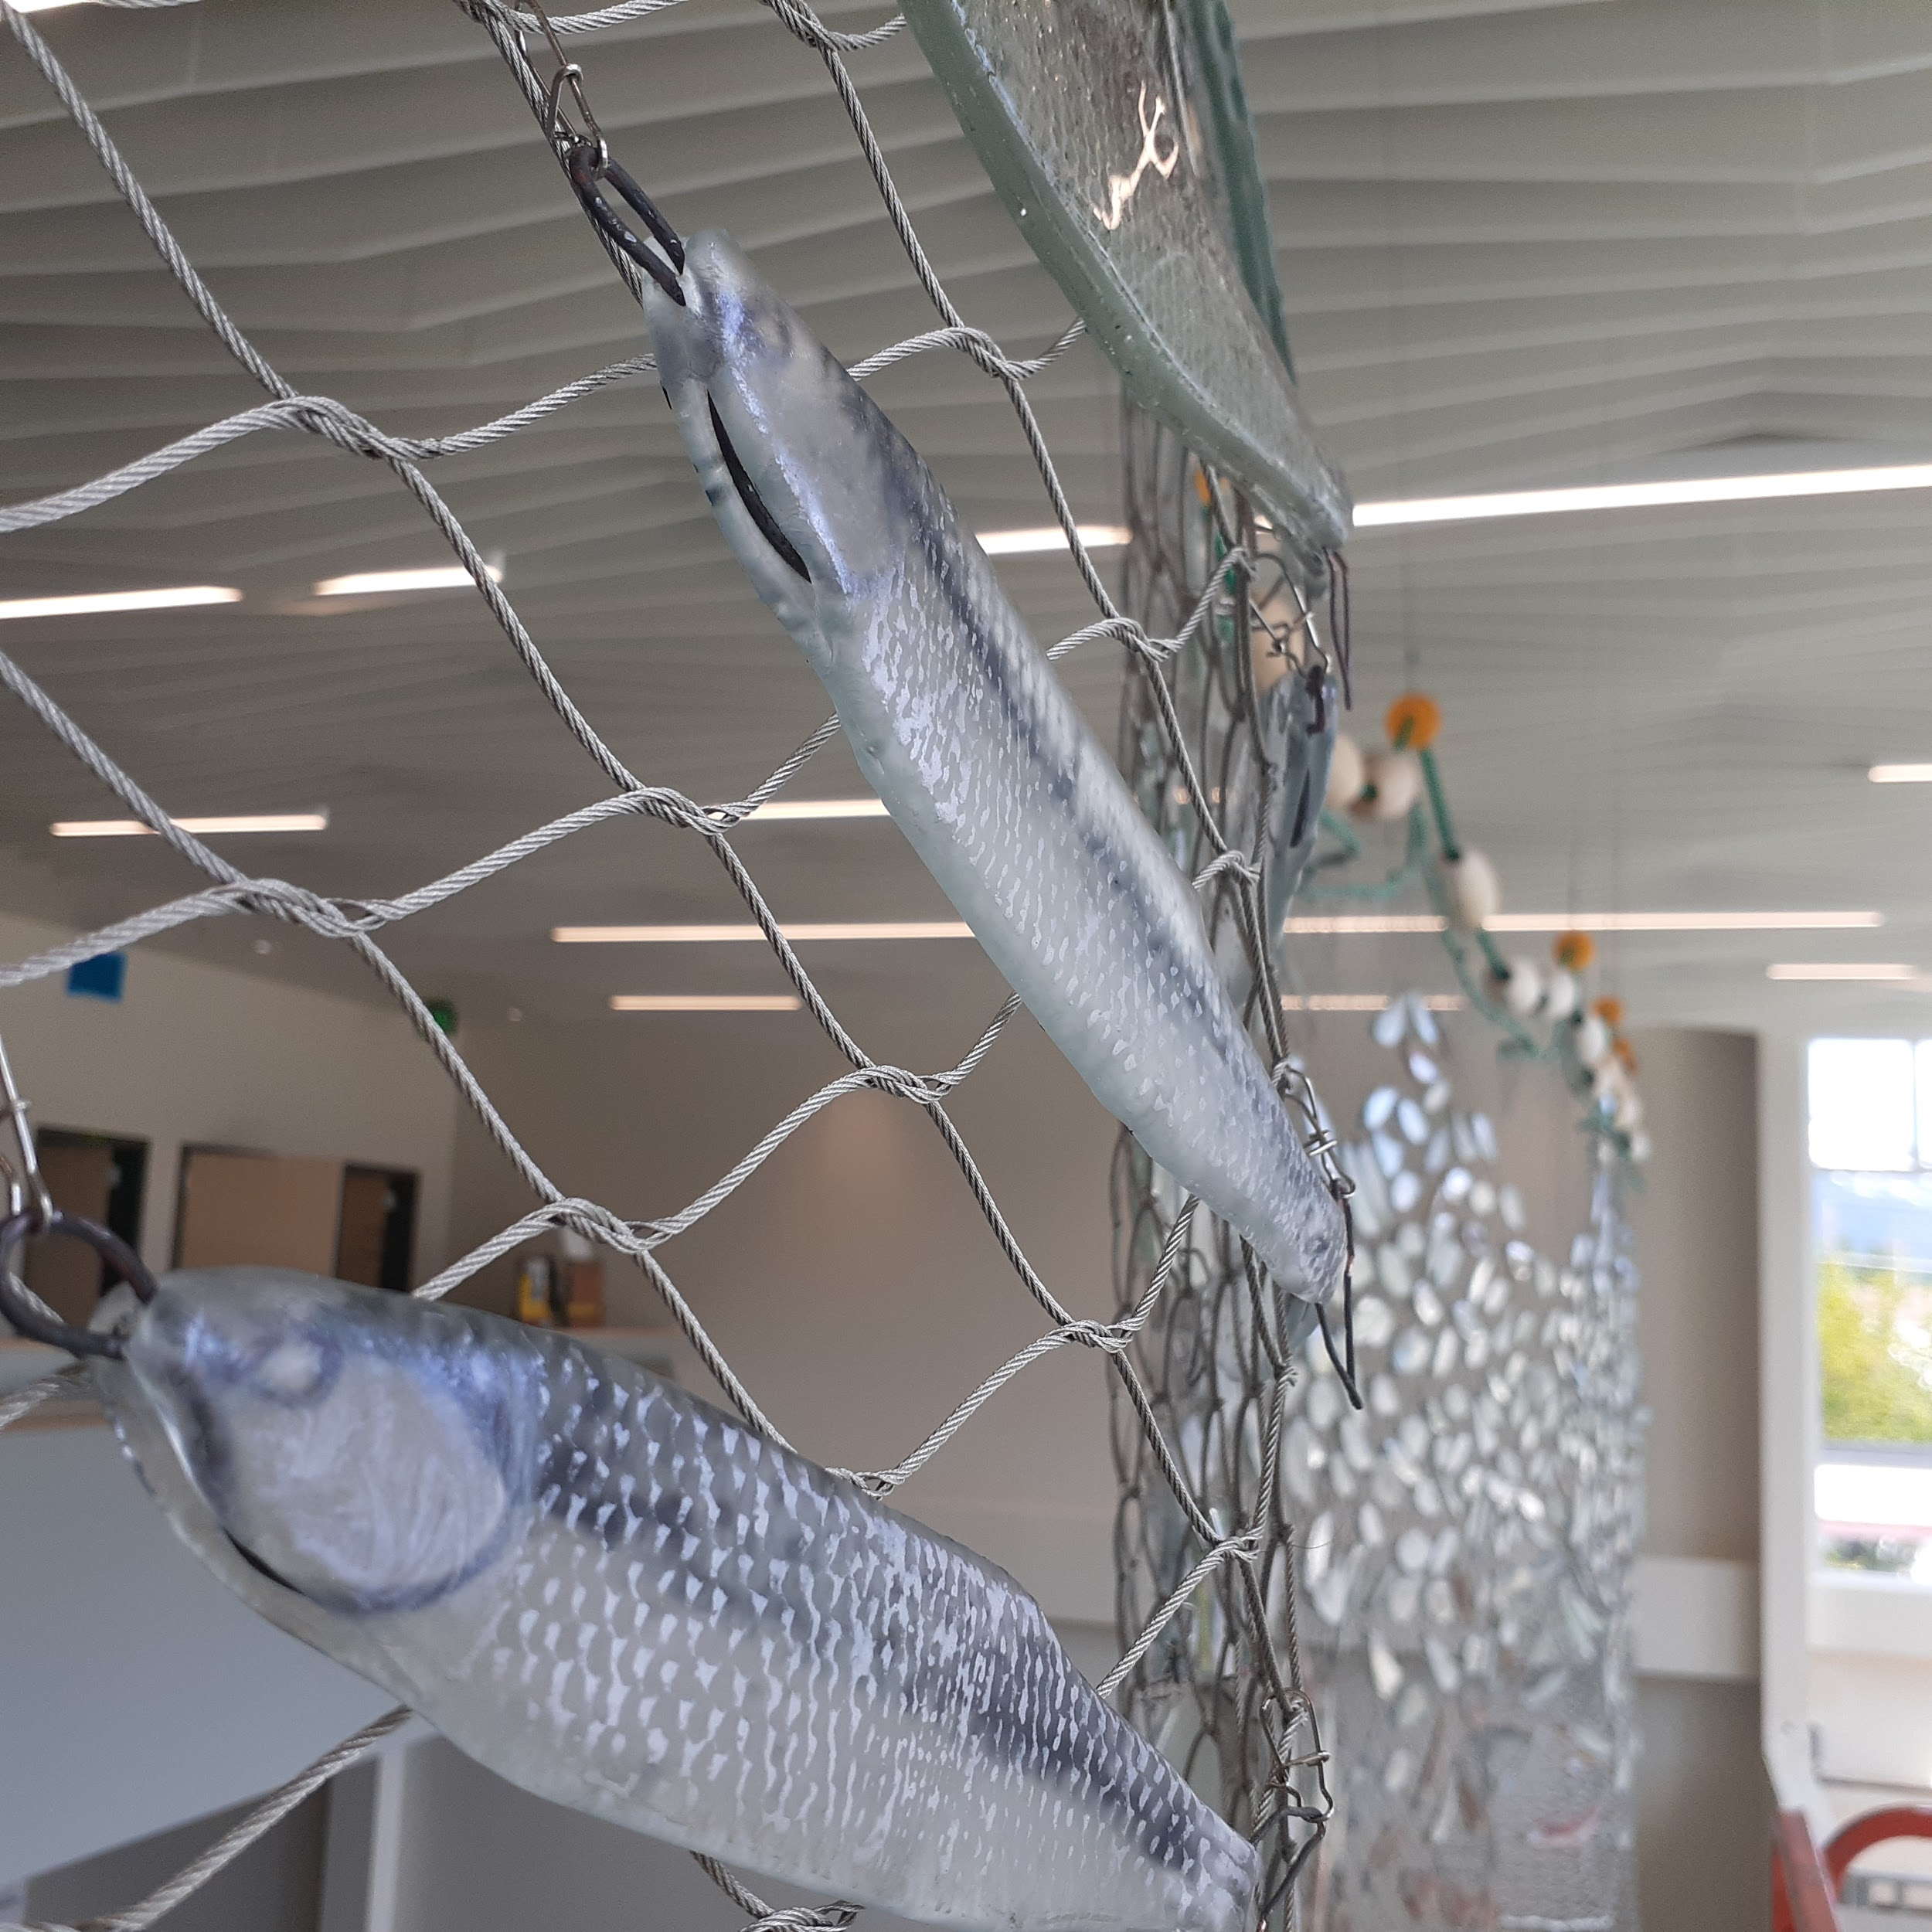

20 SEC MOVIE (on repeat)

Video ID / sCPN 13o6ZtyhIek0btCNiaLm3ql975a_QvKQc / DFAN Q6NG DW5F DRGM AEQG

Viewport / Frames 354x200*1.44 / -

Current / Optimal Res 0x0

Volume / Normalized 100% / 100%

Codecs

Connection Speed 16695 Kbps

Network Activity 0 KB

Buffer Health

ID / sCPN 13o6ZtyhIek0btCNiaLm3ql975a_QvKQc / DFAN Q6NG DW5F DRGM AEQG

Viewport / Frames 354x200*1.44 / -

Connection Speed 16695 Kbp

Video ID / sCPN 13o6ZtyhIek0btCNiaLm3ql975a_QvKQc / Z0XT 0QA6 54YP 2YQ4 RDWG

Viewport / Frames 354x200*1.44 / -

Current / Optimal Res 0x0

Volume / Normalized 100% / 100%

Codecs

Connection Speed 18944 Kbps

Network Activity 0 KB

Buffer Health